

A MINIPROJECT REPORT

Submitted by

kavin kumar (737722211\\\\\\\)

SHAIK AABID FARHAN (73772221193)

VIJAYRAJ S P (73772221218)

VISHAL P (73772221219)

in partial fulfillment of the requirement for the award of the degree
of

BACHELOR OF TECHNOLOGY
in

INFORMATION TECHNOLOGY

K.S. RANGASAMY COLLEGE OF TECHNOLOGY
(Autonomous)
TIRUCHENGODE – 637 215

MAY 2024

K.S. RANGASAMY COLLEGE OF TECHNOLOGY TIRUCHENGODE - 637 215
BONAFIDE CERTIFICATE

Certified that this project report titled “BOOK STORE MANAGEMENT SYSTEM” is the bonafide work of SANJAY S (73772221190), SHAIK AABID FARHAN (73772221193), VIJAYRAJ S P (73772221218) and VISHAL P (73772221219) who carried out the project under my supervision. Certified further, that to the best of my knowledge the work reported herein does not form part of any other project report or dissertation on the basis of which a degree or award was conferred on an earlier occasion on this or any other candidate.

SIGNATURE  S.KEERTHANA M.E.,  SUPERVISOR  Assistant Professor  Department of Information Technology  K.S. Rangasamy College of Technology Tiruchengode - 637 215 | SIGNATURE  Dr.R.Poonkuzhali, M.E.,Ph.D.,  HEAD OF THE DEPARTMENT  Professor  Department of Information Technology  K.S. Rangasamy College of Technology Tiruchengode - 637 215

DECLARATION

We jointly declare that the miniproject report on “BOOK STORE MANAGEMENT SYSTEM” is the result of original work done by us and best of our knowledge, similar work has not been submitted to “ANNA UNIVERSITY CHENNAI” for the requirement of Degree of Bachelor of Technology. This miniproject report is submitted on the partial fulfilment of the requirement of the award of Degree of Bachelor of Technology.

Signature
SANJAY S
SHAIK AABID FARHAN
VIJAYRAJ S P
VISHAL P

Place: Tiruchengode Date:

ACKNOWLEDGEMENT

We wish to express our sincere gratitude to honourable Chairman
Thiru. R. SRINIVASAN for providing immense facilities at our institution.

We would like to express our sincere gratitude to Principal Dr. R. GOPALAKRISHNAN, M.E., Ph.D. for providing the necessary resources and facilities for the completion of this project work report. Your continuous support and encouragement have been invaluable throughout this endeavour.
We proudly render our immense gratitude to the Head of the Department Dr.R.POONKUZHALI, M.E.,Ph.D., for her guidance and support in shaping the direction of this project. Your insightful feedback and expertise have been instrumental in refining our approach and methodology.
We are highly indebted to provide our heart full thanks to supervisor
S.KEERTHANA M.E., for her valuable ideas, encouragement and supportive guidance throughout the project. Your constructive criticism and attention to detail have greatly contributed to the quality of this report.
We would also like to extend our appreciation to all those who have directly or indirectly contributed to this project. Your contributions have been invaluable in making this endeavour a success.

ABSTRACT

This document outlines the design of a book store/library management system utilizing SQL for a database management system. The system focuses on managing the borrowing process and utilizes three core tables: Books, Members, and Loans.
- Books: This table stores information about the book inventory, including book ID, title, author, publication details, genre, and availability status (available, borrowed, overdue).
- Members: This table stores member information such as member ID, name, contact details, membership type (if applicable for libraries), and any outstanding fines.
- Loans: This table tracks borrowing activity with fields for loan ID, book ID (linked to Books table), member ID (linked to Members table), borrow date, and expected return date.
The document demonstrates basic SQL operations like inserting, updating, and querying data relevant to the borrowing process. Sample queries are provided for each operation, showcasing how to manage book availability, member borrowing history, and loan tracking. This design serves as a foundational framework for building a book store/library management system, and can be further customized to incorporate additional functionalities specific to individual needs.

INDEX TABLE
CHAPTER | TITLE | PAGE NO
 | ABSTRACT | 1
1 | INTRODUCTION | 3
2 | PROJECT DISCRIPTION | 4
3 | RESULT AND DISCUSSION | 5
4 | CONCLUSION | 6

CHAPTER 1

INTRODUCTION

The Book Store Management System in SQL acts as a structured and efficient hub for managing and automating various bookselling operations. This system serves as a central repository for comprehensive book information, including titles, authors, publishers, categories, stock levels, and pricing.

Streamlined Inventory Management:

Accurate Stock Tracking: The system functions like an employee payroll system in terms of maintaining real-time data. It tracks book stock levels meticulously, similar to how payroll tracks employee salaries. This allows for:

Automatic Reorder Reports: Just like payroll generates automated reports for salary adjustments, the system generates reorder reports based on predefined minimum stock levels.

Identification of Top Sellers: Similar to identifying high-earning employees, the system analyzes sales data to identify top-selling books, allowing for informed inventory management.

Automated Sales Processing:

Efficient Transaction Processing: The system processes book sales efficiently, akin to payroll processing salaries. This includes:

Tax and Discount Calculations: Similar to payroll calculating taxes and deductions, the system automatically calculates sales tax and applies any applicable discounts.

Receipt Generation: It generates receipts for each transaction, mirroring how payroll generates pay stubs for employees.

Detailed Reporting and Analytics:

Data-Driven Decisions: The system generates comprehensive reports, similar to payroll reports for financial statements. This includes:

Sales Trends: Just like analyzing payroll trends to identify high-cost departments, the system provides insights into sales trends to identify popular genres and adjust inventory accordingly.

Customer Behavior Analysis: Similar to payroll analyzing employee performance, the system analyzes customer purchasing habits, aiding in targeted marketing campaigns or loyalty programs.

Security and Compliance:

Data Protection: The system prioritizes data security, mirroring payroll's protection of sensitive salary information. It implements measures to safeguard book data and customer information, ensuring compliance with data privacy regulations.

CHAPTER 2

PROJECT DESCRIPTION

Bookstore Management System: A Streamlined SQL Solution

Imagine a system designed specifically for bookstores, mimicking the efficiency of an employee payroll system. This Book Store Management System (BSMS), built using SQL within a Database Management System (DBMS), acts as a central hub for streamlining and automating various bookstore operations.

Core functionalities of the BSMS include:

Comprehensive Book Database: Similar to an employee payroll system managing detailed staff records, the BSMS meticulously maintains a central repository of book information. This includes titles, authors, ISBNs, publishers, categories, descriptions, real-time stock levels, and prices.

Automated Inventory Management:

Stock Tracking: Just like payroll tracks salaries, the BSMS keeps a close eye on inventory levels. This facilitates automatic reorder reports when stock dips below a predefined threshold, similar to how payroll generates alerts for salary adjustments.

Top Seller Identification: By analyzing sales data, the BSMS identifies top-selling books, mirroring how payroll identifies high-earning employees. This enables data-driven decisions regarding inventory allocation and future purchases.

Detailed Reporting and Analytics:

Customer Behavior Analysis: By analyzing customer purchasing habits, the BSMS can tailor marketing campaigns or loyalty programs, akin to how payroll might analyze employee performance to optimize incentives.

Security and Compliance: The BSMS prioritizes data security, mirroring payroll's protection of sensitive salary information. It implements measures to safeguard book data and customer information, ensuring compliance with data privacy regulations.

Benefits of a BSMS:

Increased Operational Efficiency: Automating tasks like inventory management and sales processing frees up employee time and minimizes manual errors.

Improved Inventory Control: Real-time stock tracking and reorder reports ensure optimal inventory levels, preventing stockouts and overstocking.

Data-Driven Decision Making: Sales trends and customer behavior analysis provide valuable insights for informed business decisions.

Enhanced Customer Service: Efficient sales processing and the potential for loyalty programs improve customer experience.

CHAPTER 3

RESULTS AND DISCUSSIONS

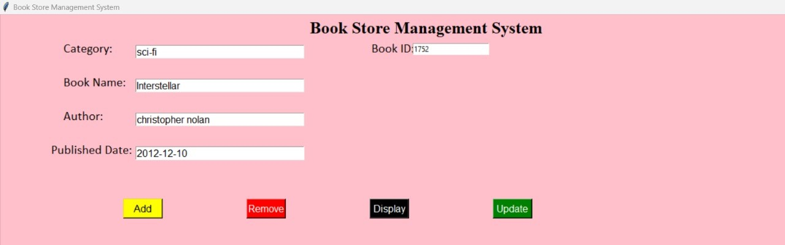

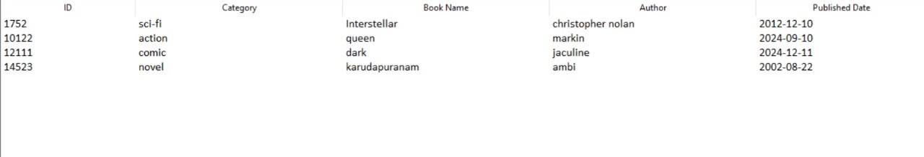

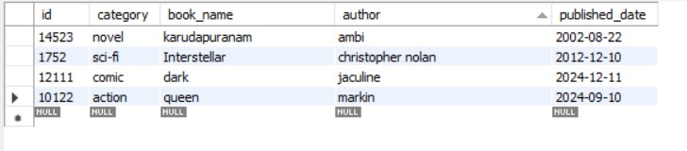

CHAPTER 4
CONCLUSION

This project provides a comprehensive overview of basic SQL operations on a relational database table. By executing these operations, the project demonstrates the practical use of SQL for creating, inserting, updating, and deleting records in a database, which are essential skills for managing data in real-world applications.
In summary, the Book Store Management System (BSMS) streamlines bookstore operations by maintaining a comprehensive book database, automating inventory management, providing detailed reporting and analytics, and ensuring security and compliance. With benefits like increased efficiency, improved inventory control, data-driven decision-making, and enhanced customer service, the BSMS empowers bookstores to thrive in a competitive market

APPENDIX

CODING

from tkinter import *

from tkinter import ttk

from tkinter import messagebox

import mysql.connector

import tkinter.font as Tkfont

root = Tk()

root.title("Book Store Management System")

root.geometry("1980x1080+0+0")

root.config(bg="pink")

root.state("zoomed")

category = StringVar()

category.set("Enter book category")

def focus_category(event):

if txt_category.get() == "Enter book category":

txt_category.delete(0, END)

txt_category.config(bg="white")

def on_focus_out_category(event):

if txt_category.get() == "":

txt_category.insert(0, "Enter book category")

book_name = StringVar()

book_name.set("Enter book name")

def focus_book_name(event):

if txt_book_name.get() == "Enter book name":

txt_book_name.delete(0, END)

txt_book_name.config(bg="white")

def on_focus_out_book_name(event):

if txt_book_name.get() == "":

txt_book_name.insert(0, "Enter book name")

author = StringVar()

author.set("Enter author name")

def focus_author(event):

if txt_author.get() == "Enter author name":

txt_author.delete(0, END)

txt_author.config(bg="white")

def on_focus_out_author(event):

if txt_author.get() == "":

txt_author.insert(0, "Enter author name")

published_date = StringVar()

book_id = StringVar()

# Connect to MySQL database

def connect_db():

try:

connection = mysql.connector.connect(

host="localhost",

user="root",

password="Root@007",

database="book_store_db"

)

return connection

except mysql.connector.Error as err:

messagebox.showerror("Database Error", f"Error connecting to database: {err}")

return None

def add_data():

add_category = txt_category.get()

add_book_name = txt_book_name.get()

add_author = txt_author.get()

add_published_date = txt_published_date.get()

add_id = txt_book_id.get()

if not all((add_category, add_book_name, add_author, add_published_date, add_id)):

messagebox.showwarning("Incomplete Data", "Please fill in all the required fields.")

return

connection = connect_db()

if connection:

cursor = connection.cursor()

try:

cursor.execute("INSERT INTO books (id, category, book_name, author, published_date) VALUES (%s, %s, %s, %s, %s)",

(add_id, add_category, add_book_name, add_author, add_published_date))

connection.commit()

messagebox.showinfo("Successfully added", "Information added successfully")

showdata()

except mysql.connector.Error as err:

messagebox.showerror("Database Error", f"Error adding data: {err}")

finally:

cursor.close()

connection.close()

def disp_data():

display_id = txt_book_id.get()

if not display_id:

messagebox.showwarning("ID Error", "Please enter an ID to display data.")

return

connection = connect_db()

if connection:

cursor = connection.cursor()

try:

cursor.execute("SELECT category, book_name, author, published_date FROM books WHERE id = %s", (display_id,))

row = cursor.fetchone()

if row:

txt_category.delete(0, END)

txt_category.insert(0, row[0])

txt_book_name.delete(0, END)

txt_book_name.insert(0, row[1])

txt_author.delete(0, END)

txt_author.insert(0, row[2])

txt_published_date.delete(0, END)

txt_published_date.insert(0, row[3])

else:

messagebox.showwarning("ID Error", f"The entered ID '{display_id}' does not exist.")

except mysql.connector.Error as err:

messagebox.showerror("Database Error", f"Error displaying data: {err}")

finally:

cursor.close()

connection.close()

def showdata():

connection = connect_db()

if connection:

cursor = connection.cursor()

try:

cursor.execute("SELECT * FROM books")

rows = cursor.fetchall()

tv.delete(*tv.get_children())

for row in rows:

tv.insert('', 'end', values=row)

except mysql.connector.Error as err:

messagebox.showerror("Database Error", f"Error fetching data: {err}")

finally:

cursor.close()

connection.close()

def rem_data():

selected_item = tv.selection()

if not selected_item:

messagebox.showwarning("Selection Error", "Please select an item to remove.")

return

selected_id = tv.item(selected_item, 'values')[0]

connection = connect_db()

if connection:

cursor = connection.cursor()

try:

cursor.execute("DELETE FROM books WHERE id = %s", (selected_id,))

connection.commit()

tv.delete(selected_item)

except mysql.connector.Error as err:

messagebox.showerror("Database Error", f"Error deleting data: {err}")

finally:

cursor.close()

connection.close()

def update_data():

update_id = txt_book_id.get()

if not update_id:

messagebox.showwarning("ID Error", "Please enter an ID to update data.")

return

connection = connect_db()

if connection:

cursor = connection.cursor()

try:

cursor.execute("UPDATE books SET category = %s, book_name = %s, author = %s, published_date = %s WHERE id = %s",

(txt_category.get(), txt_book_name.get(), txt_author.get(), txt_published_date.get(), update_id))

connection.commit()

showdata()

except mysql.connector.Error as err:

messagebox.showerror("Database Error", f"Error updating data: {err}")

finally:

cursor.close()

connection.close()

title = Label(root, text="Book Store Management System", font=("Times New Roman", 20, "bold"), bg="pink", fg="black")

title.place(x=500, y=3)

lbl_category = Label(root, text="Category:", font=("Calibri", 15), fg="black", bg="pink")

lbl_category.place(x=100, y=40)

txt_category = Entry(root, textvariable=category, width=30, font=15)

txt_category.place(x=220, y=50)

txt_category.bind("<FocusIn>", focus_category)

txt_category.bind("<FocusOut>", on_focus_out_category)

lbl_book_name = Label(root, text="Book Name:", font=("Calibri", 15), fg="black", bg="pink")

lbl_book_name.place(x=100, y=95)

txt_book_name = Entry(root, textvariable=book_name, width=30, font=15)

txt_book_name.place(x=220, y=105)

txt_book_name.bind("<FocusIn>", focus_book_name)

txt_book_name.bind("<FocusOut>", on_focus_out_book_name)

lbl_author = Label(root, text="Author:", font=("Calibri", 15), fg="black", bg="pink")

lbl_author.place(x=100, y=150)

txt_author = Entry(root, textvariable=author, width=30, font=15)

txt_author.place(x=220, y=160)

txt_author.bind("<FocusIn>", focus_author)

txt_author.bind("<FocusOut>", on_focus_out_author)

lbl_published_date = Label(root, text="Published Date:", font=("Calibri", 15), fg="black", bg="pink")

lbl_published_date.place(x=80, y=205)

txt_published_date = Entry(root, textvariable=published_date, width=30, font=15)

txt_published_date.place(x=220, y=215)

lbl_book_id = Label(root, text="Book ID:", font=("Calibri", 15), fg="black", bg="pink")

lbl_book_id.place(x=600, y=40)

txt_book_id = Entry(root, textvariable=book_id, width=20)

txt_book_id.place(x=670, y=47)

addbtn = Button(root, text="Add", font=12, bg="yellow", fg="black", command=add_data)

addbtn.config(width=6)

addbtn.place(x=200, y=300)

rembtn = Button(root, text="Remove", font=12, bg="red", fg="white", command=rem_data)

rembtn.config(width=6)

rembtn.place(x=400, y=300)

disbtn = Button(root, text="Display", font=12, bg="black", fg="white", command=disp_data)

disbtn.config(width=6)

disbtn.place(x=600, y=300)

upd_btn = Button(root, text="Update", font=12, bg="green", fg="white", command=update_data)

upd_btn.config(width=6)

upd_btn.place(x=800, y=300)

treefr = Frame(root, bg="pink")

treefr.place(x=0, y=380, width=1280, height=520)

tv = ttk.Treeview(treefr, columns=(1, 2, 3, 4, 5), show="headings")

heading_font = Tkfont.Font(family="Helvetica", size=14)

style = ttk.Style()

style.configure("Treeview", font=("Calibri", 12))

tv.heading("1", text="ID")

tv.column("1", width=50)

tv.heading("2", text="Category")

tv.column("2", width=150)

tv.heading("3", text="Book Name")

tv.column("3", width=150)

tv.heading("4", text="Author")

tv.column("4", width=150)

tv.heading("5", text="Published Date")

tv.column("5", width=100)

tv.pack(fill=X)

root.mainloop()

